Vivekanand Education Society's Institute of Technology

Department of Computer Engineering
Group No: 09
Date: 11-08-2024

Project Synopsis (2025-26) - Sem VII
Books to Mind: Agentic AI for Inclusive Learning
Dr. Sujata Khedkar
Associate Professor, Computer Engineering Department
Sarang Pavanaskar Akshat Mahajan Tanmay Maity Mohit Vaidya
V.E.S.I.T V.E.S.I.T V.E.S.I.T V.E.S.I.T

2022.sarang.pavanaskar 2022.akshat.mahajan 2022.tanmay.maity 2022.mohit.vaidya
@ves.ac.in @ves.ac.in @ves.ac.in @ves.ac.in

Abstract
This project proposes the development of an agentic AI-powered educational assistant to make that will implement fine-tuned Large Language Models (LLMs) to simplify and narrate school curriculum content from NCERT/State Boards for students with Special Educational Needs (SEN). The system focuses on two key capabilities:
- Simplifying academic text to multiple difficulty levels for better comprehension.
- Converting curriculum concepts into engaging, easy-to-follow stories.
Unlike generic text simplification tools, this tool is curriculum-aware and integrates Retrieval-Augmented Generation (RAG) to ensure factual accuracy. By combining Parameter-Efficient Fine-Tuning (PEFT) techniques like LoRA/QLoRA with prompt-controlled generation, the system adapts outputs to suit different learning needs. The agentic design allows the AI to work semi-autonomously — recommending when to simplify, narrate, or provide contextual examples — thereby reducing educator workload and improving inclusivity in classrooms.

Introduction
In India, school education is largely standardized through the NCERT and State Board curricula. While this ensures uniformity, it often fails to cater to cognitive diversity in classrooms. Students with SEN, including dyslexia, autism, and intellectual disabilities, struggle with dense language, abstract concepts, and limited engagement in traditional learning materials.
At the same time, the rise of agentic AI — intelligent systems capable of proactive and goal-aligned behavior — offers a transformative opportunity in education. This project builds on that opportunity, aiming to create an educational AI assistant that not only answers questions but also actively adapts learning material for SEN learners. The work aligns with the vision of NEP 2020 for inclusive and personalized education.

Problem Statement
Challenges in Current Educational Material:
- Accessibility Gap – Textbooks use complex vocabulary and syntax, making them difficult for SEN learners.

- Personalization Gap – Teachers manually adapt lessons for each student, which is time-consuming and hard to scale.

- Engagement Gap – Traditional content lacks relatable narratives, leading to reduced attention and interest.
Most existing NLP tools are reactive, generic, and lack curriculum alignment, making them unsuitable for specialized educational needs.

Proposed Solution
We propose a novel framework that functions not merely as a tool, but as an agentic educational assistant. At its core, the system offers a dual functionality:
(1) A multi-level text simplification engine that reframes complex curriculum content into clear, accessible language, and
(2) A pedagogical narrative generator that converts abstract concepts into engaging stories.
To ensure all outputs are factually sound and aligned with the NCERT/State Board syllabi, the system is built on a Retrieval-Augmented Generation (RAG) architecture. This grounds every generation in specific, retrieved curriculum chunks, preventing factual inaccuracies. Furthermore, we will employ Parameter-Efficient Fine-Tuning (PEFT) techniques like LoRA/QLoRA to efficiently adapt a powerful base LLM, specializing it for the Indian educational context and the linguistic needs of SEN learners.
The most innovative aspect is the agentic control logic. Instead of passively waiting for commands, the system will proactively analyze uploaded material and recommend actions, such as simplifying a dense paragraph or generating a story for a difficult topic. This entire solution will be delivered as a user-friendly, web-based tool, making it a scalable and accessible resource for educators, parents, and students, thereby bridging the educational gap in an inclusive manner.

It provides:
- Stronger Verbs & Professional Tone: Replaces generic terms with more descriptive ones (e.g., "Dynamically adapts," "Transforms," "Ensures," "Leverages").

- Explains the "Why": It doesn't just list the technologies (RAG, PEFT) but briefly explains why they are being used (to ensure accuracy, for efficiency).

- Highlights Innovation: The "agentic" nature of the project is brought to the forefront and explained more clearly as a key differentiator.

- Better Structure: The points are organized logically, flowing from the user-facing features to the underlying technology that powers them.

Methodology
Phase 1: Dataset Creation
- Digitize NCERT/State Board textbooks (Classes 1–10).
- Generate SFT dataset using GPT-4/Gemini for instruction-based tasks
- Include control tokens (<LEVEL_1>, <STORY_GEN>) in prompts
Phase 2: Architecture Design
- Select an open-source LLM (LLaMA 3, Mistral 7B, etc.).
- Build a RAG pipeline using FAISS for vector retrieval and LangChain for orchestration.
- Implement decision logic for agentic behavior.
Phase 3: Model Training
- Fine-tune the base model using PEFT (LoRA/QLoRA) for efficiency.
- Train on consumer-grade GPUs.
- Enable prompt-controlled generation for different complexity levels.
Phase 4: Web-based Prototype
- Develop frontend in React.js.
- Backend with FastAPI for model inference and API handling.
- Allow text upload or manual entry, with automatic AI suggestions.
Phase 5: Evaluation
- Measure simplification accuracy, readability, and factual alignment.
- Conduct educator and student testing for real-world validation.

Block Diagram

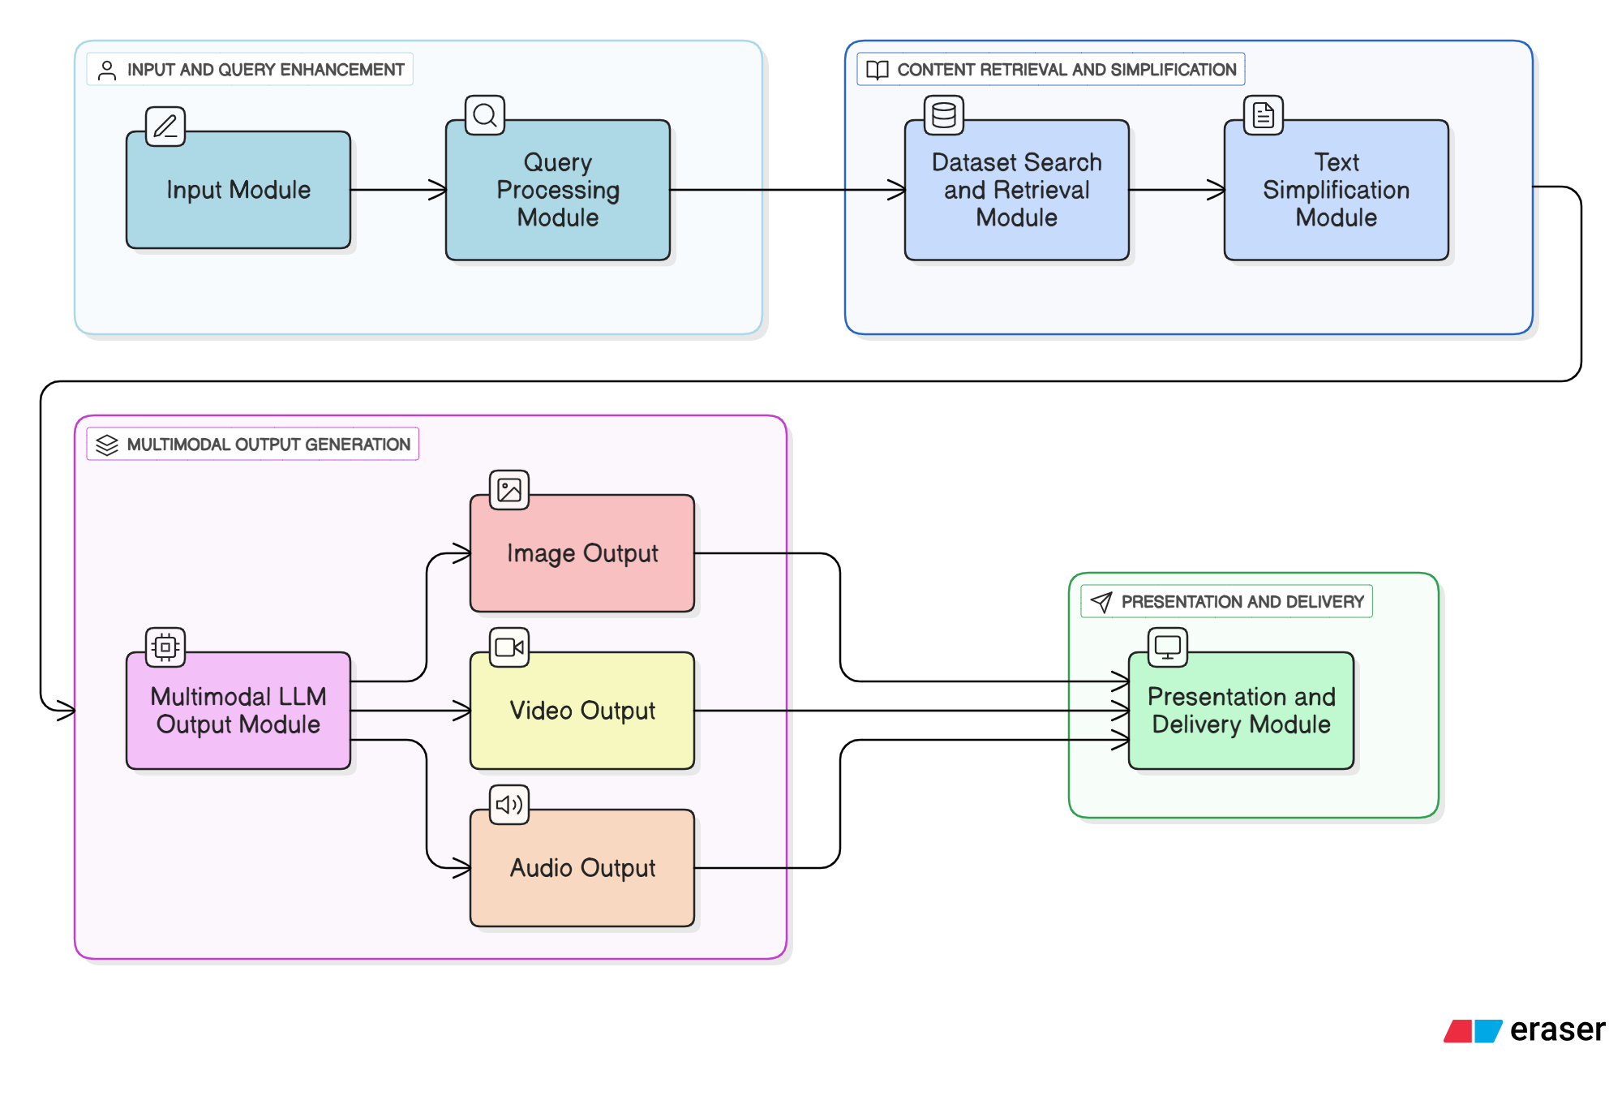

Hardware, Software, and Tools Requirements
Software:
- Language Modeling: PyTorch, Hugging Face Transformers, PEFT, Accelerate
- Retrieval: FAISS / ChromaDB, LangChain or LlamaIndex
- Frontend: React.js
- Backend: FastAPI or Flask
- Dataset Creation: GPT-4, Gemini 1.5 Pro
- Deployment: Docker, AWS
Hardware:
- Training: 1× NVIDIA A100 or 2× RTX 3090 GPUs
- Hosting: Server with 8–16 GB RAM (GPU optional for inference)
- Development: Laptop with at least 16 GB RAM

Proposed Evaluation Measures
Quantitative:
- Simplification Accuracy: ROUGE-L, BLEU, BERTScore
- Readability: Flesch-Kincaid Grade Level
- Factual Alignment: NLI-based consistency checks
Qualitative:
- Educator Feedback: SUS scores, interviews
- Student Comprehension: A/B testing with quiz scores
- Engagement Metrics: Time on task, ease-of-use ratings

Conclusion
This project aims to transform how NCERT and State Board content is delivered to SEN learners. By combining simplification, storytelling, and agentic decision-making, the system bridges accessibility, personalization, and engagement gaps. The integration of RAG ensures factual accuracy, while PEFT fine-tuning makes the solution efficient to train and deploy. The result is an AI assistant that empowers educators, engages students, and supports truly inclusive education — in line with India’s NEP 2020 goals.

References

[1] A. Säuberli et al., “Digital comprehensibility assessment of simplified texts among persons with intellectual disabilities,” CHI 2024.
[2] NCERT, Report of the National Focus Group on Education of Children with Special Needs, 2005.
[3] M. K. Siahaan, “Education for children with special needs,” ExplorA, vol. 8, no. 2, 2022.
[4] A. Madan and N. Sharma, “Inclusive education for children with disabilities: preparing schools to meet the challenge,” EJIE, vol. 3, no. 1, 2013.
[5] O. Henkel et al., “Retrieval-augmented generation to improve math question-answering,” EDM 2024.
[6] P. Martínez et al., “Exploring large language models to generate easy to read content,” Front. Comput. Sci., vol. 6, 2024.
[7] E. J. Hu et al., “LoRA: low-rank adaptation of large language models,” arXiv:2106.09685, 2021.
[8] T. Dettmers et al., “QLoRA: efficient finetuning of quantized LLMs,” arXiv:2305.14314, 2023.
[9] Y. Huang and J. Huang, “A survey on retrieval-augmented text generation for large language models,” arXiv:2404.10981, 2024.
[10] E. Madjidi and C. Crick, “Towards inclusive reading: a neural text generation framework for dyslexia accessibility,” DSAI 2024.
[11] L. Rello et al., “Simplify or help? Text simplification strategies for people with dyslexia,” W4A 2013.
[12] J. Swacha and M. Gracel, “Retrieval-augmented generation chatbots for education: a survey,” Appl. Sci., vol. 15, 2025.
[13] M. Färber et al., “SimplifyMyText: an LLM-based system for inclusive plain language text simplification,” arXiv:2504.14223, 2025.
[14] P. S. Ajmal et al., “Intellecta cognitiva: a comprehensive dataset for advancing academic knowledge and machine reasoning,” arXiv:2404.13065, 2024.
[15] K. Vyas and S. Bano, “Education for children with special needs: Journey from segregation to inclusion,” Arch. Ment. Health, vol. 16, no. 1, 2015.

